HealthApp Automation

Social Service Module

Excel-Based updated Document

Pre-requisite:

As soon as you import project in eclipse, update the project using maven update option as below. This is to resolve issue if any maven dependency not downloaded properly:

1. Right click on project : Go to “Maven” : Select “Update Project”

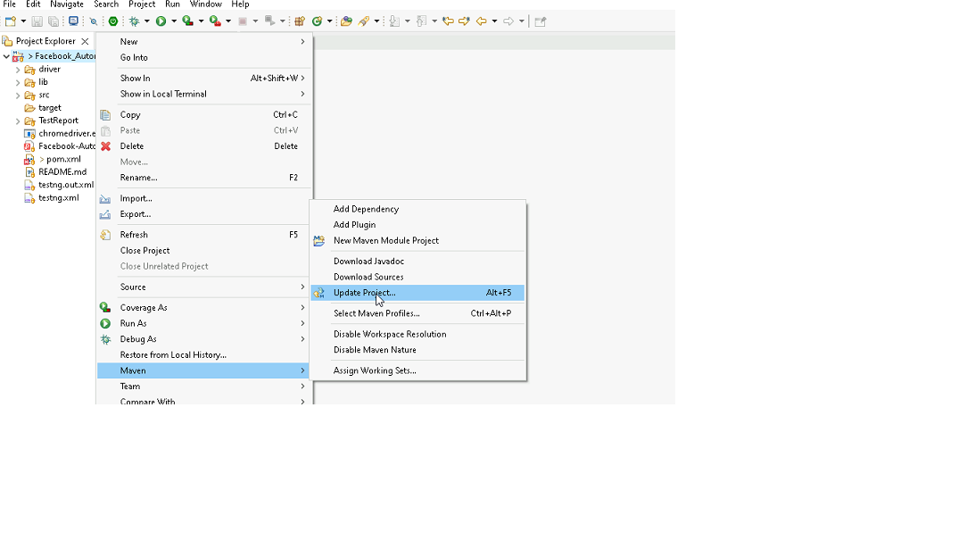

1. In Update Maven Project Box Select “Force Update of Snapshots/Releases” and click OK

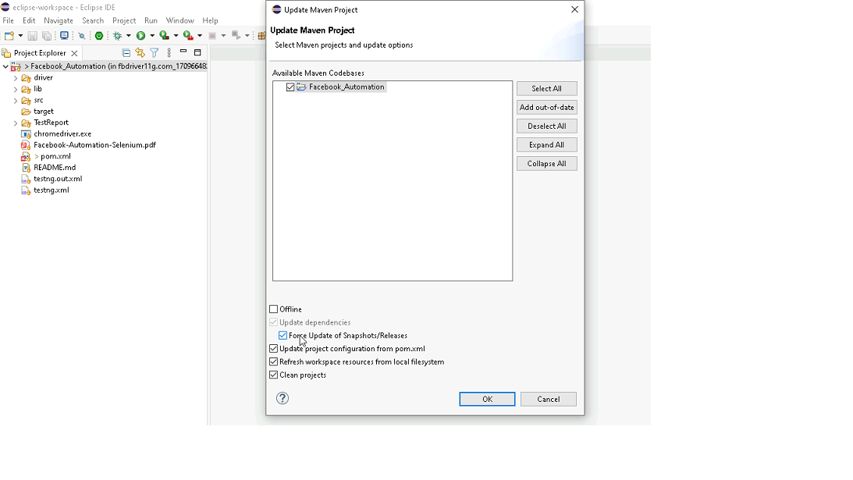

Template Code Structure:

1. Below are the packages and files you will be required to work upon.
2. Other Files and packages you can ignore.
3. In other Files and packages do not do any changes. It would affect your evaluation.
4. You are not required to work in “Test” Folder. Files there are non-editable. Editing those files and trying to save them will throw error and would affect your evaluation.

|  |  |  |
| --- | --- | --- |
| **Package** | **Class/File** | **Description** |
| src/main/java/coreUtilities/utils/ | FileOperations.java | 1. Contains methods to read from excel file. 2. Method is in templated form. 3. **You will be required to implement these methods as very first activity, because even URL to navigate to, is read using these methods.** |
| /src/main/java/pages | socialService_Pages.java | 1. All core activities (mentioned in list above) to be performed here. 2. The comments associated with each templated method here describe the expectation. 3. You can define locators and xpath here. 4. Declare any variable/object you need to share data/status between different methods. 5. Do not modify the signature of methods declared here. 6. You can create additional supportive common methods in CommonEvents class. |
| /src/main/resources/ | Config.xlsx | URL to navigate to: Already URL is defined here |
|  | expected_data.xlsx | Contains data to fill in form |
| /src/main/java/coreUtilities/utils | CommonEvents.java | 1. Contains all common activities. 2. Certain templated common method declared here. 3. You implement them as per your need. 4. You can add any additional method for common activity here |
|  | Testng.xml | Execution needs to kick started from TestNG xml |

PROBLEM STATEMENT

Need to automate the following activities using Selenium + Java.

Key Activities to implement:

|  |  |  |  |
| --- | --- | --- | --- |
| **Sl No.** | **Summary** | **Action** | **Expected Result** |
| **1** | Verify the title and url of the current page. | 1.  go to url :[**https://healthapp.yaksha.com/**](https://healthapp.yaksha.com/)  2. login as valid credential **(username : admin , password : pass123)** and click on "**SignIn**" Button                                                                               3. get the title and url of the Home page, post login  4. validate the title and url of the Home page | Title should be : **DanpheHealth**  Url should be : **https://healthapp.yaksha.com/Home/Index#/** |
| **2** | Verify that **SocialService** module is present or not ?  If Social Service Module is present then Then go to SocialService Page. | 1. user must be logged in 2. Check **SocialService** module **is present** in left navigation 3. Click on the **SocialService** Module | User successfully navigate to the **SocialService** page |
| **3** | Verify that **Register New SSU Patient** button is present inside the SocialService page and when we click on **"Register New SSU** **Patient"** button , it popup "**New SSU Patient Registration**" form. | 1.User is on SocialService page 2. find and click on "**Register New SSU Patient"** button and verify the form Name /title is "New SSU Patient Registration" | user should found the "**Register New SSU Patient**" button, clicking on it and open the "**New SSU Patient Registration**" form. Form title /name should be **"New SSU Patient Registration"** |
| **4** | On the "**New SSU Patient Registration"** form**,** Validate the error message in **Last Name** textfield without filling any data and clicking on "**Register"** Button | 1. click on "**Register**" button directly without fill any information in **"New SSU Patient Registration"** form's 2. then an error message will display under the **Last Name** textfield. 3. then validate the error message. | Error message should be : **Last Name is required** |
| **5** | On the **"New SSU Patient Registration"** form's validate that **First Name, Middle Name & Last Name textbox** are present or not ? If present then fill the below textbox : **First Name textbox Middle Name textbox Last Name textbox**  Check the data which we are entered are present in **First Name** textbox or not ? | 1. user must be On the "New SSU Patient Registration" form's 2. verify theFirst Name, Middle Name & Last Name textbox is present ? 3. if Present then Enter data in the First Name textbox 4.Enter data in the Middle Name textbox. 5.Enter data in the Last Name box. 6. then verify the value which is present in First Name textbox. | On the **"New SSU Patient Registration"** form's below textbox should be present: **First Name textbox Middle Name textbox Last Name textbox**  The entered data should be correctly displayed in First Name textbox on "**New SSU Patient Registration**" form. |
| **6** | On the Social Service module's, **"New SSU Patient Registration**" form, select **India** from the **country** dropdown and validate India is properly selected or not. | 1. on the Social Service Module, user must be on **"New SSU Patient Registration**" form 2. Select country as **India** in the country dropdown in "**New SSU Patient Registration**" form | User should able to select India as country from the country dropdown menu. |
| **7** | scroll to the bottom of the **"New SSU Patient Registration"** form and verify that **"Register"** button and "**Close**" button are peresent or not? | 1. User must be on **"New SSU Patient Registration"** form. 2. scroll to the button of the "**New SSU Patient Registration**" form 3. verify that "**Register**" button and "**Close**" button are peresent or not? | user should be perform the scroll operation and "**Register**" button and "**Close**" button should be present. |
| **8** | Validate that the following warnning message is existing in "**SSU Information"** Section of the **"New SSU Patient Registration**" form. | 1. User must be present on **"SSU Information"** Section of **"New SSU Patient Registration"** form 2. validate the warning message (**Membership Scheme(s) is Mandatory**) existing ? | warning message should be : **Membership Scheme(s) is Mandatory.** |
| **9** | On "**New SSU Patient Registration"** form's, in the "**SSU Information"** section, select "**Yes**" from the **"Has target group certificate?"** dropdown. Verify that "**Target Group Certificate Type"** textbox and "**Certificate No."** textbox is coming after select the "**Yes"** from dropdown. | 1. User must be present on **"SSU Information"** Section of **"New SSU Patient Registration"** form 1. Go to "**Has target group certificate?"** dropdown 2. select "yes" from  **"Has target group certificate?"** dropdown 3. Verify that **"Target Group Certificate Type"** and **"Certificate No."** textbox is coming after select the "**Yes**" from the  **"Has target group certificate?"** dropdown. | **"Target Group Certificate Type"** textbox and **"Certificate No."** textbox should be displayed after select the "Yes" from **"Has target group certificate?"** dropdown. |
| **10** | On the "New SSU Patient Registration" form's, get the place holder name of "**Address**" textfiled of "**New SSU Patient Registration**" page and verify the place holder name. | 1. user must be present on "**New SSU Patient Registration**" form's.  2. click on "**Address"** Textfield 3. Then get the place holder name of "**Address"** text field  4. verify that place holder name and print on console. | placeholder name should be "**Address**" and then print on console |
| **11** | On the "**New SSU Patient Registration**" form, Close this "**New SSU Patient Registration**" popup page by using javaScript. | 1. user must be present on **"New SSU Patient Registration"** form's.  1.Click on the "**X**" / close button using javaScript | "**New SSU Patient Registration**" popup page should be closed. |
| **12** | navigate back to the home page , refresh the current page and then verify that **Registered Patient, Total Doctors** & **Today's Appointments** fields are present or not? Then navigate forward to the social service module's **SSU PatientList** page and then verify that "**SSU Patient List"**  button & **"Register New SSU Patient"** button are present or not ? | 1. user must be present on **"SSU Patient List"** page 3. navigate back to the home page using navigation back method 4. refresh the using navigation refresh method 5. verify the below fields are present or not in home page: **Registered Patient,  Total Doctors Today's Appointments**  6. then forward to the social service module's SSU **PatientList** page using navigation method 7. then verify below buttons are present on **SSU Patient List** page: **"SSU Patient List"  "Register New SSU Patient"** | user should be navigate back , refresh and able to see the below fields in home page  **Registered Patient,  Total Doctors Today's Appointments** then user should forward to the **SSU Patient** List page and able to see the below buttons : **"SSU Patient List"  "Register New SSU Patient"** |
| **13** | On the Social service module's, in the "SSU Patient List" page , locate the **"Edit Information Of" patient**  textbox using "ID" locator and verify the locator name is "**id"** or not ? | 1. user must be present on "**SSU Patient List**" page of social service module  2. locate the **"Edit Information Of patient"** textbox using "ID" locator 3. get the locator name  4. validate that locator value. | locator value should be : **ID** |
| **14** | On Procurements Module's Setting page, select the Sub Category Tab and fetch the Sub-Category Name for the given code (Code - 0003) and validate that Sub Category name. | 1. Go to the "Procurement" modules 2. go to the setting page 3. select the "Sub Category" Tab 4. fetch the Sub-Category Name for the given code (Code : 0003) | user should be able to fetch and validate the data from Specified table. |
| **15** | On Procurements Module's Setting page, select the **Items** Tab, then click on "**Add** **Item**" Button which popups **"Add Item"** form. Then select the "**GENERAL-INVENTORY"** radio button and check whether is the radio button is selected or not.  After the validation deselect the "**GENERAL-INVENTORY**" radio button. | 1. user must be present on "**Sub Category**" Tab of Procurement module's Setting page 2. clcik on the "**Items**" Tab 3. click on **"Add Item"** Button, then "Add Item" form will popups. 4. select the **"GENERAL-INVENTORY**" radio button  5. verify that , **"GENERAL-INVENTORY"** radio button is selected or not  6. if **"GENERAL-INVENTORY**" radio button is selected then deselect the "GENERAL-INVENTORY" radio button. | user should be select the **"GENERAL-INVENTORY"** radio button then user should able to deselect the "**GENERAL-INVENTORY**" radio button |
| **16** | On the Add Item form's Select/check the below check boxes : **1. Is Cssd Applicable check box 2. Is Cold Storage Applicable check box 3. Is Patient Consumption Applicable check box** verify that the above check boxes are selected or not ? after the validation, Uncheck the above check box. | 1. user must be present on Add Item form's 2. Select/check the below check boxes : **Is Cssd Applicable check box Is Cold Storage Applicable check box Is Patient Consumption Applicable check box** click on **"Add Item"** Button, then "Add Item" form will popups. 5. verify that ,the above check boxes are selected or not  6. after the validation, Uncheck the above check box. | user should be check the all check boxes and after validation unchek the all checkboxes. |

NOTE: "Please do not delete any file in the src folder.  But you are free to add any other file".

Expectations:

1. Learners should write automation script using Java and selenium to automate all the steps in the above question. In other words, automation script should perform all mentioned steps.
2. Learners should not use any tools to create the xpath. They should develop the xpath/cssselector on their own.

IMPLEMENTATION/FUNCTIONAL REQUIREMENT

* 1. **CODE QUALITY/OPTIMIZATIONS**
     1. Associates should have written clean code that is readable.
     2. Associates need to follow SOLID programming principles.

EXECUTION STEPS TO FOLLOW

1. **You are mandatory required to run test cases for applications before final submission. Without which project evaluation will not happen.**
2. **You can launch test cases any time as follows: Right click on testng.xml and run TestNGSuite**

|  |
| --- |
|  |

1. **Before final submission, you are also required to push your code to GIT. Following are the steps to follow:**

|  |
| --- |
|  |

In your project folder, you will find a batch file named git_commands

|  |
| --- |
|  |

Double-click the batch file to run it. It will run the commands to push your code to GIT.

|  |
| --- |
|  |

===============================================================================

All the Best